Discussion Board
Author Name
Institutional Affiliation

Giraffes Can’t Dance.
Giraffes can't dance, is the title of the book that was written by Giles Andreae, published by Hachette and illustrated by Guy Parker Rees. The book is a story that can be read by children between the age of six and nine. The book begins with a description of the giraffe's image named Gerald. Gerald is tall with long and slim legs with crooked knees and a tall neck (Andreae, 1999). Gerald cannot run around as he falls off when he tries to do so. It's that time of the year when all animals held the jungle dance, and these made Gerald unhappy as he was not good at dancing.
During the dance, lions danced the tango, warthogs walted, while rhinos rolled, monkeys and baboons danced in circles too. When Gerald walked to the dance floor, all animals screamed after him, which scared him and walked back home. Gerald met with a cricket who played the violin for him on his way home, and he started dancing so well that the other animals came to have a look, and they were all surprised and agreed that Gerald was the best dancer they have ever seen (Andreae, 1999). The story ends with Gerald responding to all animals that anyone can dance, provided they have the right tune.
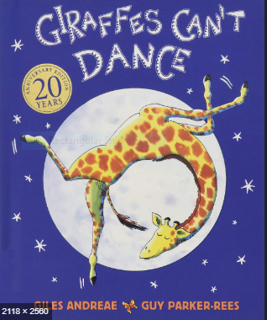

The book is significant to young children as it encourages language development in various ways. First, the book opens a child to new ideas; for instance, the book has pictures of different animals that the child gets to learn apart from giraffe such as monkeys, rhinos, lions, baboons, among other animals. Through reading the book, children learn the sounds, phonics, and rhythms important in language development (Dickinson et al., 2012). An example in the book is the description of how the chimps were dancing to cha cha (Andreae, 1999). The book also helps the children to develop and build vocabulary.
The book enhances cognitive development in children. Cognitive development in children is their ability to explore, think, and figure out things. When the book is read to the children aloud, it helps them create imaginations about the story. Children also try to connect with their own lives, thus enhancing cognitive development. Making connections about the story in a child's brain cells is essential as it strengthens them, and new brain cells are formed (Kalb & Van Ours, 2014). For instance, the description of giraffe's image; a tall neck, skinny legs, and bent knees help a child's perception, thus cognitive development.
The book enhances moral and social development in children in various ways. First, children get to learn how to accept their differences and those of others. For instance, Gerald is a different creature from the others as he is very tall, and his inability to dance disappoints him. In the end, Gerald dances amusing other animals a fundamental moral lesson to children that one can be different and still do things in their way. Through the book, children learn the importance of friendship and self-love, which are significant aspects of social development. Children also get to learn that they should not prejudice others but accept them the way they are. For instance, the lion refers to Gerald as clumsy, which angers him and decides to walk away.
I would recommend this book to parents to read it out to their children as its one of my favorite books. It helps children to develop different aspects in their life, such as cognitive development, language development, moral and social development. The book is also fun to read with beautiful and colorful illustrations with which children can identify. Through the book, children learn how to create their own identity.

References
Andreae, G. (1999). Giraffe’s Can’t Dance.
Dickinson, D. K., Griffith, J. A., Golinkoff, R. M., & Hirsh-Pasek, K. (2012). How reading books fosters language development around the world. Child Development Research, 2012.
Kalb, G., & Van Ours, J. C. (2014). Reading to young children: A head-start in life? Economics of Education Review, 40, 1–24.

References

